Background Paper on Electricity Network Codes
September 2014

The completion of the Internal Market in Electricity is a key priority for energy regulators and has been the focus of our work for many years. Regulators are keen to ensure that the Third Package’s rules are put in place as soon as possible and that the benefits which an integrated market can provide are passed on to European energy customers. Regulators have played, and will continue to play, a central role in developing rules, ensuring they’re implemented as quickly as possible and in sharing experience and best practice. As we stand at a point where the Comitology process for the first set of binding rules in electricity is about to begin, we consider that there is value in summarizing the position to date and briefly looking ahead to future challenges.
Establishing the Target Model
The Target Model is the common vision for a European electricity market which regulators, the European Commission and colleagues from the TSO community (via the European Network of Transmission System Operators for Electricity (ENTSO-E)) are seeking to put in place. Regulators were involved in establishing the Target Model through ERGEG (the European Regulators Group for Electricity and Gas), which existed prior to the founding of ACER.
The 15th Florence Forum in November 2008 invited ERGEG to establish a Project Coordination Group which would bring experts and stakeholders together to develop a common design for European electricity markets. Through this work the first proposal for the Target Model was presented to the 17th Florence Forum in December 2009.
The Florence Forum supported ERGEG’s proposal to continue the work of the Project Coordination Group through the Ad Hoc Advisory Group (AHAG) which brought together all stakeholders. Regulators in ERGEG chaired 10 AHAG meetings between 2010 and 2011 which developed a series of regional implementation projects through which practical experience of market integration could be developed and valuable experience, which would feed into the Framework Guidelines, gathered.
Regulators thus made a significant contribution to the preparatory work which laid the foundations for the Third Package. From an early point we supported the concept of using guidelines - which became the Framework Guidelines - to set out the blueprints from which legally binding rules would be developed.
Since that time European regulators have taken the lead on early implementation of the Target Model, establishing and chairing the ACER Electricity Stakeholder Advisory Group (AESAG), developing and scrutinizing cross-regional roadmaps, and through regular reporting via the Electricity Regional Initiatives and the Florence Forum.
The Third package

The Third Package went further than previous initiatives to liberalise energy markets by setting out a process to develop the rules which would implement the Target Model and allow the completion of the internal electricity market. Perhaps the central pillar of the Third Package was the development of Network Codes in a number of areas identified in the Third Package and refined by the Commission in its annual priority setting cycle.
The process of developing the electricity Network Codes, shown below, includes specific roles for regulators (with cooperation overseen by ACER), for ENTSO-E, for the Commission and for Member States.
The process begins with the European Commission requesting ACER to develop Framework Guidelines in a particular area. While non-binding from a legal perspective, Framework Guidelines set the baseline against which rules must be developed and act as the benchmark against which proposals are assessed. Within 6 months, ACER must provide clear and objective principles for developing the Network Code, consult on the Framework Guideline and submit the Framework Guideline to the European Commission.
The European Commission then requests ENTSO-E to develop and submit a Network Code in line with the Framework Guideline to ACER within a 12 month period. Within this period ENTSO-E is expected to engage with a broad range of stakeholders to ensure it comes up with a balanced set of proposals.
Once the proposed Network Code is submitted to ACER, it must then provide a ‘reasoned opinion’ as to whether the Network Code is in line with the Framework Guidelines and, once it is satisfied this is the case, it may also recommend the adoption of the Network Code to the European Commission. This process is shown below.
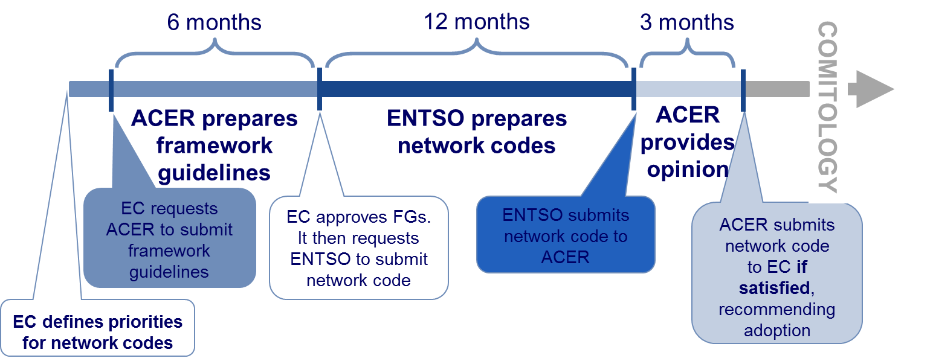
Once a recommendation has been received, the European Commission has the option to present a text to Member States participating in the Cross-Border Committee who are able to vote on the text as part of the ‘Comitology’ process.
After a positive vote by the Committee, a Network Code will be scrutinised by both the Council and the European Parliament. Each party has three months in which it may object to the code based on three limited legal grounds. If either legislator objects then the Network Code will be rejected. If none of them opposes the code, the Network Code is adopted as a European law.
The Framework Guideline phase
The 3rd Package provisions came into effect in March 2011. During the period between September 2009 and March 2011 (the so called "interim period)", ERGEG took the initiative to "act as if it were ACER" in preparing (for input to ACER) draft Framework Guidelines, to ensure that ACER would be able to hit the ground running when its formal responsibilities came into effect. ERGEG followed the timeframes and procedures set out in the Third Package.
During the interim period, ERGEG worked on a three Framework Guidelines in electricity, in the following areas:
- electricity grid connection;
- electricity capacity allocation and congestion management; and
- electricity system operation.

This work allowed ACER to make considerable progress and it launched consultations on fully drafted Framework Guidelines within days of legal operation starting in March 2011. The first Framework Guidelines on Capacity Allocation and Congestion Management (CACM) and Grid Connections in Electricity were finalised and published by July of that year and Electricity System Operation in December. A fourth Framework Guideline, on electricity balancing, was consulted on between April and June 2012 and adopted in September of that year.
The approach taken by ACER was similar across both electricity and gas. ACER sought to set out the principles and key subject areas to be covered within Network Codes at a relatively high level, while being sufficiently detailed to allow for focused drafting.
The table below shows the dates for “as if” consultations by ERGEG and formal consultations by ACER, as well as the dates on which ACER adopted the Framework Guidelines.
Framework Guideline | ERGEG Consultation | ACER Consultation | ACER Adoption
Elec Grid Connection | 12/7/2010 – 24/9/2010 | 3/3/2011 – 2/5/2011 | 20/6/2011
Elec CACM | 10/9/2010 – 10/11/2010 | 11/4/2011 – 10/6/2011 | 29/7/2011
Elec System Operation | N/A | 15/7/2011 – 15/9/2011 | 2/11/2011
Elec Balancing | N/A | 25/4/2012 - 25/6/2012 | 18/9/2012

In all cases ACER issued Framework Guidelines within the 6 month timeline. This included a public consultation. In all cases for electricity, the EC accepted the Framework Guidelines as submitted and asked ENTSO-E to start drafting the corresponding Network Code(s).
The Network Code development phase
ENTSO-E also started work at an early stage with “as if” pre-work in parallel with the ACER work on Framework Guidelines. This was particularly the case on their ‘pilot’ Network Code on Requirements for Generators.
As ENTSO-E and ENTSOG began to develop approaches to drafting Network Codes, it became clear that fairly different approaches were being taken between gas and electricity. In particular:
- ENTSO-E proposed to develop multiple Network Codes to meet each Framework Guideline. This reflected a view that the volume of work would be such that developing codes incrementally was the only feasible approach and was agreed via the planning group (the forum comprising the two ENTSOs, ACER and the Commission). The Commission reflected this decision in its requests to ENTSO-E to begin drafting Network Codes. The consequence was that nine Network Codes have so far been developed to meet four Framework Guidelines (with more to come).
- Perhaps reflecting the relatively more interconnected nature of electricity networks as opposed to gas networks, ENTSO-E adopted a more technical, less legislative approach to drafting than ENTSOG. A particular feature of this approach involved using the approach, also found in the third package, of referring to approval of detailed rules and methodologies at national or regional level.

During the early stages of Network Code drafting, stakeholders and stakeholder organisations raised concerns about ENTSO-E’s engagement. In particular these concerns related to the volume of consultation and the extent to which stakeholders were able to influence Network Code texts once drafted. It is notable that ENTSO-E substantially revised its approach in light of initial experience in order to give greater opportunities for interaction.
The development of the CACM Network Code was slightly different to other codes in that the Commission chose to develop a Governance Guideline in parallel to the Network Code. This reflected the fact that decisions about the allocation of roles and responsibilities between actors in the sector was best taken by the European Commission. However, both documents were developed with the Target Model in mind, ensuring overall coherence. Indeed, both documents were eventually merged in a single text.
In all cases ENTSO-E delivered Network Codes on or before the deadlines specified in the invitation letter from the European Commission. In all cases this included a public consultation and multiple discussions with stakeholders.
The ACER review phase
As we noted above, once a Network Code is submitted to ACER by ENTSO-E, ACER has 3 months to deliver its reasoned opinion on whether the network code is in line with the Framework Guideline. If satisfied, ACER may recommend the network code to the EC.
At first there were differing interpretations as to how this part of the process should work between ACER and ENTSO-E. However, an established way of working has developed over time. In developing its reasoned opinion, it was not always possible for ACER to formally consult but, where appropriate, ACER has used open stakeholder workshops to allow parties to provide views.
ACER assessed each submitted Network Code against the relevant Framework Guideline to establish whether it was in line with that guideline. In some cases it also identified issues which it considered would enhance the Network Code, though which didn’t relate directly to compliance with the Framework Guideline.
In all cases, ACER found that much of each Network Code was in line with the corresponding Framework Guideline. In most cases, ACER also found some areas where this was not the case. Where such differences were identified, ACER issued a reasoned opinion and provided ENTSO-E with the option to work further on the Network Code and to resubmit an adapted version. ENTSO-E took decisions about whether to take up this option on a code specific basis, choosing not to work further on CACM, but choosing to make amendments to the connection and system operation related Network Codes as well as to the Network Code on electricity balancing. This is shown in the diagram below. Once a revised version was received, ACER issued a recommendation, identifying important unaddressed issues if need be.

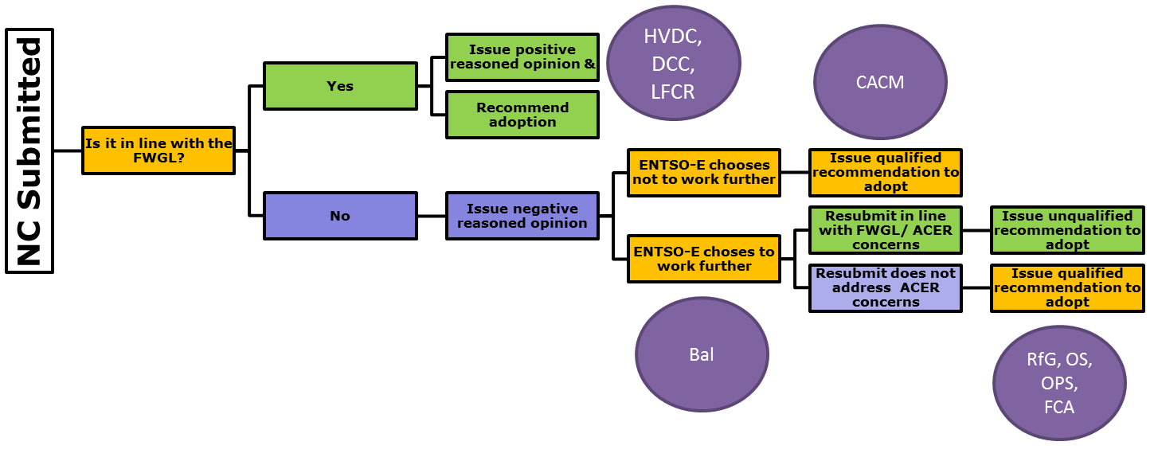
Throughout this stage, the process tended to involve a series of trilateral meetings in which the Commission was closely involved. In particular the Commission emphasized the need for outstanding issues to be resolved quickly in order to allow rapid adoption.
Where the Network Codes were resubmitted by ENTSO-E, ACER’s recommendations were typically issued very soon after resubmission. The ACER decision was issued 1 ½ months after receipt for the Forwards, Operational Security and Operational Planning and Scheduling Network Codes and less than a month after receipt for the Requirements for Generators Network Code.
ACER hit the 3 month deadline for issuing a reasoned opinion in 100% of cases. By the middle of 2013, three Electricity Network Codes had been recommended; by the end of 2013 a further three had been recommended. As of August 2014, a total of eight Electricity Network Codes have been recommended to the Commission.
The table below shows the timings for each milestone within the Network Code development process completed so far, from Framework Guideline completion to ACER recommendation.

 | Framework Guideline Completion | NETWORK CODE Submission to ACER | ACER Opinion on NETWORK CODE | ACER Recommendation
Grid Connection FG | 20/7/2011
RfG |  | 13/7/2012  8/3/2013* | 13/10/2012 | 25/3/2013
DCC |  | 4/1/2013 | 25/3/2013 | 25/3/2013
HVDC |  | 30/4/2014 | 24/7/2014 | 24/7/2014
CACM FG | 29/7/2011
CACM |  | 22/9/2012 | 19/12/2012 | 14/3/2013
Forwards |  | 1/10/2013  3/4/2014* | 18/12/2013 | 22/5/2014
Balancing | 18/9/2012 | 23/12/2013 | 21/3/2014 | Not yet issued
System Operation FG | 2/12/2011
OS |  | 28/2/2013  24/9/2013* | 28/5/2013 | 11/11/2013
OPS |  | 29/3/2013  24/9/2013* | 19/6/2013 | 11/11/2013
LFC&R |  | 28/6/2013 | 26/9/2013 | 26/9/2013
* Network Code resubmitted by ENTSO-E
For the Balancing Network Code (the only code submitted by ENTSO-E which has not yet been recommended by ACER), the next stage is expected to be resubmission by ENTSO-E.
The process of resubmission has led to some delays relative to the initial ambitious timetables adopted by the Planning Group (see for example the Planning Group’s timetable from December 2011 as set out in the Annex). For example, for CACM the ACER Recommendation was made in March 2013 rather than December 2012 as originally expected.
The EC proposal phase
The next phase of the Network Code adoption process involves the Commission making a proposal to the relevant Comitology committee. As of August 2014, eight out of nine Electricity Network Codes are in this phase.
For understandable reasons, it has been challenging for the European Commission to progress eight Network Codes in parallel and progress has recently not been as expected. Despite the EC’s significant contribution to, and involvement in, the development of the Target Model, the Framework Guidelines, and the Network Codes, their review of the Network Codes which followed the recommendation by ACER led to a large number of additional issues being raised, which needed to be resolved.
Once these issues were addressed, the inter-service consultation for CACM has led to significant further issues coming to light. The resolution of these issues, and the sequential way in which Network Codes have been assessed, has led to a position where none of the Network Codes for electricity will be adopted before the end of 2014. For example, for CACM, the formal Comitology process did not start in Q1 of 2013 as envisaged in the December 2011 plan, nor in Q2 of 2013 as would have been expected from the delay in bringing the Network Code into line with the Framework Guideline (explained above) but is expected in Q4 of 2014.
During this phase the Commission has used informal Comitology committee meetings to familiarise Member States with the content of the first Network Codes to be adopted. There have also been discussions on the most substantive issues from a stakeholder perspective via the Florence Forum. However changes to the text in light of EC’s internal comments may have reduced the benefits of this as Member States have been unable to analyse final texts. In addition, the recent changes, analysed below, of treating some of the electricity regulations as guidelines as opposed to Network Codes has been perceived as a significant change in direction, at a very late stage.
There is no deadline in the Third package for the EC to submit a final text to the Comitology process. Therefore the EC has not missed (or met) any formal deadlines. The timings have been significantly delayed compared to the 3 year plans published by the EC (such as the example in the Annex).
The Comitology phase

It is our current understanding that the EC intends to start the formal Comitology phase for the first electricity Network Code (as a Guideline) in October 2014. Depending on progress, there could be a vote in the committee to adopt the code before the end of 2014, but the formal adoption (with scrutiny and publication) will not be possible before 2015. It is hoped that multiple codes can be adopted in the first half of 2015.
Once voted on by the Comitology committee, the Council of the European Union and the European Parliament have 3 months to object to the proposal under defined legal grounds (Regulatory procedure with scrutiny, Article 5a). Following this, the Network Code or Guideline is published in the Official Journal and enters into force after 20 days.

The Implementation phase
The adoption of a Network Code or Guideline does not mean that all its provisions enter into force at that point. In many cases, the codes are drafted so that most of the important provisions come into effect at a later date. The periods for implementation are code specific, but typically range from 2 to 3 years. In some cases, most notably in the balancing Network Code, final arrangements will not be in force until 6 years after adoption. Hence adoption in 2015 is likely to mean that the benefits that the Network Codes deliver are not felt until 2017/18 in general and, possibly as late as 2022 for some aspects.
From ACER’s perspective, it is important to recognise that the process of implementing the codes will be both important and resource-intensive for involved parties (including NRAs). ACER has an important role in monitoring implementation. It is also recognised that the process of subsequent amendments to the codes will be very important. ACER has already set out a proposed process for dealing with amendments.
Network Codes or Comitology guidelines
Recent advice from the European Commission’s legal service has led to a change in the process with some documents that were developed as Network Codes being instead taken forward as guidelines. Understandably, these changes have caused some concern.
In particular, the European Commission announced at the Florence Forum in May 2014 that the former CACM Network Code will be a Guideline, while emphasising that it will have the same legal effect. After having closely analysed the amendments, ACER is of the view that the two routes to create European Regulations are broadly similar; though there are important distinctions.
For both Network Codes and Guidelines only the Commission can make proposals to the Comitology Committee. The EC can then only amend the Network Code or Guideline following a positive vote in that Committee and after the period for Council and Parliament scrutiny has passed.
The major difference is that once a Guideline enters into force, only the Commission can propose amendments which must pass through the Comitology Committee. If the Regulation takes the form of a Network Code then all interested parties may propose amendments via a process which ACER has outlined.
The Commission has stated that it will insert provisions into the Guidelines to mirror this process and allow for stakeholder involvement in guidelines, which ACER fully supports. However we note that this text was not included in the most recent version of the CACM Network Code text. As noted above, ACER considers that the amendment process will be of utmost importance. ACER’s support for proceeding with CACM as a guideline is based on the inclusion of the Network Code method of gathering and evaluating amendments.
Conclusion
ACER considers that a pragmatic approach to Network Code adoption is needed and recognises that the initial codes won’t be perfect. However, we consider that the Electricity Target Model and Framework Guidelines based on it – developed several years ago now - have stood the test of time well. We note that developing robust, flexible and inclusive approaches to amending Network Codes and guidelines in future will be important and note that ACER has already published a proposed process and explored this issue in our Bridge to 2025 consultation.
The development of Network Codes has been a long process and has involved a very significant commitment from all parties. While there have been some benefits for customers as a result of early implementation projects, it is critical that the full benefits of the internal market in electricity are realized by adopting the Network Codes as quickly as possible and implementing their provisions in full, across Europe.

ANNEX
As an example of the expected timetable for adoption of the Network Codes, which drove the work by ACER and ENTSO-E, we include a plan published by the European Commision in December 2011. The equivalent current plan is published on the Commission’s website.

See CEER conclusions paper on Implementing the Third Package
Excess of competences laid out in Regulation 714, incompatibility with the aim or content of Regulation 714, violation of subsidiarity & proportionality.
Though this may change if the proposed switch to Delegated Acts replaces the Regulatory Procedure with Scrutiny under Article 5a.

